

CaSA – Pre-Launch Engagement Session, Sunamganj
Avoidable Deaths Network
Background and Context
The haor region of Sunamganj District, situated in the Sylhet Division of Bangladesh, is one of the country’s most vulnerable landscapes due to flood and lightning. The area is characterised by vast, bowl-shaped wetland basins that undergo dramatic seasonal transformation — relatively dry and accessible during winter, then submerged under deep floodwaters throughout the monsoon season. This cyclical flooding, while ecologically rich, exposes communities to acute and recurring disaster risks.
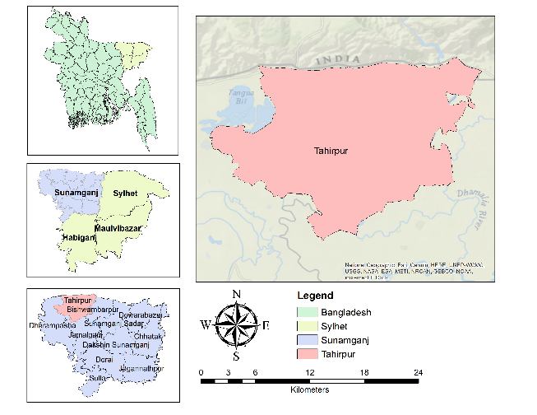
Figure 1: Study Area Map — Tahirpur Upazila, Sunamganj District, Sylhet Division, Bangladesh. Photo: ADN.

During the pre-monsoon period, farmers venture into open fields to harvest crops — activities that coincide with intense electrical storms, putting them at heightened risk of lightning strike. As the monsoon advances, fishermen take to the open water in large numbers during storms, facing both flash flood-induced drowning and lightning hazards simultaneously. Children are disproportionately affected, as seasonal flooding creates persistent drowning risks. These deaths are, in large part, avoidable — and it is this recognition that motivates the establishment of a community Case Station in the area.
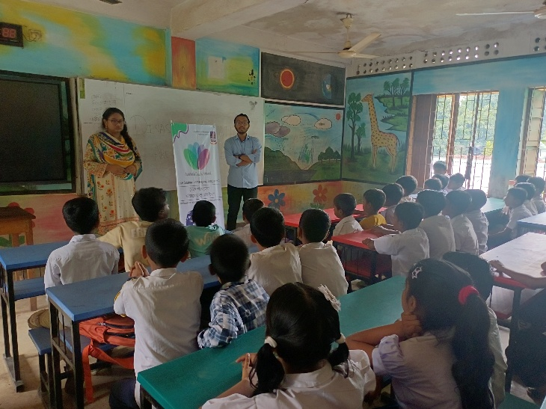
Pre-Launch Engagement Session in Progress — Moddho Tahirpur Government Primary School. Photo: ADN.
Session Overview
As part of the early-stage preparatory work for a community-focused Case Station (CaSA) in the haor region, a pre-launch engagement session was conducted at Moddho Tahirpur Government Primary School in South Sreepur, Tahirpur Upazila, Sunamganj District. The session was held with Class 4 and Class 5 students and was designed to explore existing levels of awareness of local disaster risks among young community members.
The session was facilitated by ADN future leaders and interns Sadia Afrin Sayfa Negaban and Mohammad Fahimul Islam, along with Maisha Farzana Methila and Jayeef Rahman Muaz, under the academic supervision of

Associate Professor Dr. Fatima Akter, Department of Meteorology, University of Dhaka — Bangladesh Chapter Host of ADN. 40 students participated over 45 minutes, engaging actively and showing strong curiosity throughout.
Key Topics Discussed
The session centred on two primary hazards posing the greatest threat to life in the haor region: Lightning and Flash Flood.
Hazard 1: Lightning
Lightning is one of the deadliest hazards in the haor region, particularly during the pre-monsoon season (March–May). Farmers in open agricultural fields face acute vulnerability as the flat terrain offers virtually no shelter. The lack of early warning systems in rural communities further compounds exposure. Students discussed:
- Recognition of warning signs: darkening skies, rumbling thunder, sudden wind shifts, and static electricity in the air.
- Safe behaviours during a storm: seeking enclosed shelter, avoiding open fields, water bodies, and isolated trees.
- Household awareness: communicating lightning safety measures to parents and siblings who work outdoors.
- Community responsibility: neighbours alerting one another and promoting early evacuation from fields.

Hazard 2: Flash Flood
Flash flooding is the defining seasonal reality of haor life. From April through the monsoon months (June–September), the haor basins fill rapidly, catching communities with little time to prepare. Children are among the most affected. Fishermen venturing onto open water face compounded risks from flash floods and lightning. The session addressed:
- Understanding flash flood behaviour: how quickly water can rise and the importance of not underestimating inundation speed.
- Child safety near water: the critical role of adult supervision and keeping children away from water bodies.
- Fishermen’s safety: checking weather conditions and avoiding open water during storms.
- Student as safety messenger: encouraging students to share knowledge with family members who fish or work outdoors.
Student Responses and Community Engagement
The students responded with strong enthusiasm and active participation throughout both hazard discussions. Several students shared first-hand accounts from within their own communities — describing neighbours and known individuals who had lost their lives to lightning strikes or flash flood-induced drowning in recent years. These testimonies were a powerful reminder of the immediate, lived reality of these risks and underscored the urgency of sustained awareness and preparedness efforts in the area.
A key emphasis of the session was the role of children as active messengers of safety within their households and broader communities. The facilitators highlighted that knowledge shared with students does not remain confined to the classroom — children naturally carry what they learn home, sharing it with parents, grandparents, and siblings. A child who understands lightning safety can remind a farming parent to seek shelter; a child who understands flash flood drowning risks can alert a younger sibling to stay away from flooded pathways.

Plan of Action
- Formal Launch of CaSA: Moving towards a full community launch, bringing together local government representatives, health workers, community leaders, disaster responders, and school authorities.
- Expanded School Engagement: Additional awareness sessions rolled out across schools in the haor region, reinforcing lightning and flash flood safety messaging.
- Community-Wide Outreach: Awareness activities extended to adult community members, with a focus on farming households and fishing communities.
- Development of Local Level Action Network (LAN): A village-level LAN established to identify local solutions and create a sustained community of practice.
- Long-Term Monitoring and Impact Assessment: A follow-up evaluation planned five years after the Case Station launch to assess impact on community awareness, preparedness, and mortality rates.

The session made clear that these hazards are recurring, seasonal realities that families navigate every year. This context gives the forthcoming Case Station its purpose and urgency. The planned CaSA in Tahirpur will be the first of its kind in Bangladesh, addressing Lightning and Flash Flood risks facing this wetland community.
© Avoidable Deaths Network (2025)

