Nominate Your Community Hero for the Avoidable Deaths Network’s (ADN) Hero Award

Every day, ordinary people take extraordinary actions to protect others, reduce disaster risks, and strengthen their communities. Some save lives through innovation. Others mobilise neighbours to solve neglected problems ignored during or post disasters. Many work quietly, by driving a snakebite victim on their motorbike to the nearest hospital without recognition, yet their impact saves lives and transforms entire communities.
Now is the moment to bring those stories forward.
We invite you to nominate individuals whose courage, leadership, and commitment have prevented harm, protected lives, or created safer futures. Whether they introduced a simple idea that changed everything, rallied a community to act, or stood up when no one else would, their story deserves to be told. Because they are unsung heroes.
If you know someone who has:
- Reduced preventable injuries or deaths
- Led a community-driven safety or risk-reduction initiative
- Overcome barriers to protect others
- Created measurable, lasting change
Submit a nomination today to shine a light on the next ADN Hero. Each year, one ADN Hero Award is announced; however, exceptions may be made depending on the volume of nominations. The outcome of the Hero Award will be announced on 12 March, and the awardee will be invited to receive a certificate and the opportunity to speak with their nominator on 31 March at ADN’s virtual International Awareness Day for Avoidable Deaths closing ceremony at 1:00 PM (GMT).

Deadline to nominate: 25 February 2026

Submit your nomination: To nominate your community hero, email this completed submission form to contact@avoidable-deaths.net with the subject heading: “Hero Award Nomination - HAN26).”

Our First Hero
The ADN Hero Award 2025 went to ADN Regional Coordinator, Ms. Tahira Khan for her amazing work to reduce avoidable deaths from well fall in Pakistan.
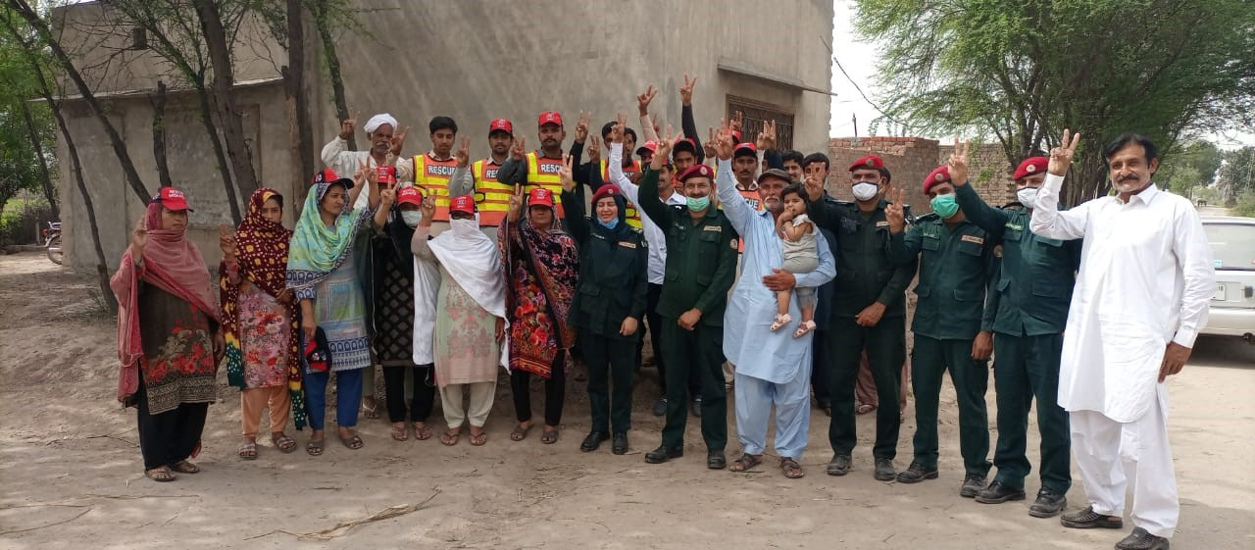

Hero Selection Criteria
The Hero Awards are selected by an ADN Panel of Experts, chaired by the ADN Presidents, Professor Nibedita Ray-Bennett and Dr. Hideyuki Shiroshita. The Panel of Experts applies eight selection criteria, using the criterion most relevant to each case.

1. Demonstrated Life-Saving Impact
Nominees must have taken actions that directly prevented loss of life or significantly reduced the risk of serious injury. Evidence may include:
- Documented reduction in fatalities or injuries
- Clear before-and-after change attributable to the nominee’s intervention
- Protection of both human life and community assets (e.g., livestock, livelihoods)

2. Innovation in Risk Reduction
The nominee should have introduced or championed a practical, scalable, and context-appropriate solution to a persistent safety or disaster-related problem. This may include (although not limited to):
- Frugal or low-cost or resource-efficient innovations
- Adaptation of local knowledge or community resources
- Creative problem-solving in the absence of formal funding or institutional support

3. Community Mobilization and Leadership
Nominees must demonstrate exceptional leadership in engaging, motivating, or organizing their community to address a shared risk. Indicators include:
- Successful mobilization of volunteers, local groups, or beneficiaries
- Behaviour change achieved through awareness-raising or advocacy or outreach workshops for and with high-risk and vulnerable individuals or communities.
- Evidence of trust, respect, and influence within the community

4. Overcoming Systemic or Structural Barriers
The nominee should have acted despite institutional, financial, cultural, or logistical obstacles, showing persistence and courage. Examples include:
- Implementing solutions without government funding
- Challenging harmful norms or long-standing practices
- Working in high-risk, underserved, or remote environments

5. Measurable and Sustainable Results
The initiative must show clear, verifiable outcomes and demonstrate potential for long-term sustainability. This may include:
- Significant reduction in incidents, injuries, or economic losses
- Continued community ownership or maintenance of the solution
- Replicability in other communities or regions

6. Ethical Conduct and Community Well-Being
Nominees must uphold ethical, inclusive, and community-centred values, such as:
- Respect for local culture and dignity
- Prioritization of vulnerable groups (children, youth, marginalized populations)
- Transparent and accountable decision-making

7. Personal Commitment and Sacrifice
The award recognises individuals who have shown extraordinary dedication, which may include:
- Voluntary service beyond their formal role
- Personal risk, hardship, or sacrifice
- Long-term commitment to protecting others

8. Evidence of Transformational Change
The nominee’s actions should have shifted community norms, perceptions, or behaviours, such as:
- Changing attitudes toward preventable risks
- Establishing new safety practices or standards
- Inspiring others to take action or replicate the initiative

Scoring Framework
Each criterion is scored on a 0–5 scale, where:
0 = Not demonstrated
1–2 = Partially demonstrated
3–4 = Strongly demonstrated
5 = Exceptional, transformative impact
This allows for transparent, defensible decision-making across diverse nominees.

Submission Form

1. Nominee Details (if successful, name, country of the nominee will be used for our website and social media posts)
Title
Name
Role
Institution
Country
Email
Phone Number

2. Your Details (If your nomination is successful, with your permission we will mention your name in our website and social media posts)
Title
Name
Role
Institution
Country
Email
Phone Number
Permission | Yes or No?

3. Why Are You Nominating This Person? If successful, excerpt of this information will be used for our website and social media posts.
Within 200 words, tell us what they did and why it matters.

4. What Impact Did Their Actions Have? If successful, excerpt of this information will be used for our website and social media posts.
Share any results you know such as lives protected, risks reduced, community benefits, etc. Please do not use more than 100 words

5. Anything You’d Like to Add? If successful, excerpt of this information will be used for our website and social media posts.
Photos, links, or a short note of appreciation (no more than 100 words)

6. Declaration
I confirm the information provided is accurate to the best of my knowledge.
Name
Date

