Avoidable Deaths Network’s Achievements and Highlights January – December 2024
Knowledge Exchange Events | Publications | Projects | Partner Engagements | Outreach | Future Leaders | Outcome
UNOCHA-HNPW:  5 speakers  78 registrants  Special Sessons Webinars (3):  20 speakers  283 registrants | 3 Bulletins:  Winter-Spring: 807 Recipients, 33.21% opened  Spring-Winter: 868 Recipients, 34.22% opened  Winter-Spring: 967 Recipients, 41.47% opened  1 Newsletter:  807 Recipients 14.87% opened  1 Annual Report  4 Technical Reports  2 Peer-Review Articles  ADN Junior Champion Magazine Vol.2 | 3 completed  4 ongoing | 1 stakeholder dissemination and feedback workshop:  15 participants  4 countries  3-day symposium:  9 speakers  174 registrants  7 partners  13 countries  Santiago Network bid:  25 technical experts  7 future leaders 26 partners  10 countries | 960 Affiliates (increase by 19%)  1324 LinkedIn followers (increase by 33%)  206 Instagram followers (increase by 18%)  ADN main site view: 6,444  Memberships:  UNDRR’s Voluntary Commitment Platform for Sendai Framework (since 2022)  Institute for Environmental Futures (since 2023)  UNOCHA Networks and Partnerships Group under the Leading-Edge Programme (since 2024)  Santiago Network (since 2024)  Global Campaign International Awareness Day for Avoidable Deaths (IAD4AD):  Year 1  Marked across 13 countries  50+ activities  506 participants  IAD4AD site visit: 465  Case Station for Avoidable Snakebite Deaths (CaSA):  7 outreach workshops  338 participants | 62 Junior Champions  4 Future Leaders Interns  4 Future Leaders | Contributed to:  Sendai Framework’s Targets A&B  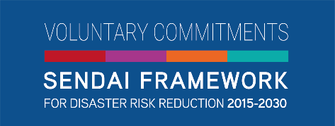  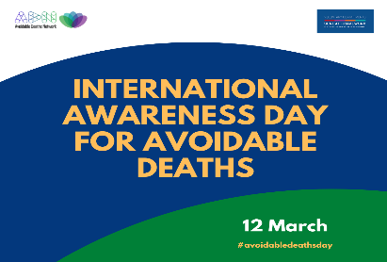  SDGs 3, 6, 11, 13 & 17

